Financial Life Cycle Mathematics


Credit Scores: A Mathematical Exploration
A Module for Data Science & Financial Mathematics using Excel
Jack Marley-Payne, Philip Dituri, Andrew Davidson
Unit Contents
Topic 1: Introduction to Credit Scores
Topic 2: Components of Credit Scores—Consumer Perspective
Topic 3: Consumer Behavior, Correlations, and Credit Scores
Topic 4: What is a Credit Report?
Topic 5: Credit Reports to Attributes
Topic 6: Credit Scores, Probability and Odds
Topic 7: Delinquency and Logistic Regression
Topic 8: Evaluating Models and Creating a Credit Score
Topic 9: Are You Your Credit Score?
Table of Contents
Essential Understandings 4
Content Progression In Spreadsheet Materials 5
Topic 1: Introduction to Credit Scores 9
Where do Credit Scores Come From? 12
Topic 1: Check for Understanding 14
Topic 2: Components of Credit Scores—Consumer Perspective 15
Topic 2: Check for Understanding 19
Topic 3: Consumer Behavior, Correlations and Credit Scores 21
Spreadsheet Connection: T3 Credit Score Correlations 30
Topic 3 Check for Understanding 31
Topic 4: What is a Credit Report? 35
Spreadsheet Connection: T4A Fruitstand 37
Spreadsheet Connection: T4b Credit Data Functions 37
Spreadsheet Connection: T4c Credit Data Single Consumer 38
Topic 4 Check for Understanding 40
Topic 5: Credit Files to Attributes 42
Spreadsheet Connection: Attributes NBA 42
Spreadsheet Connection: T5a VR Glasses by Attribute 44
Spreadsheet Connection: T5b CS 20 20 45
Spreadsheet Connection: T5c Quartiles 48
Topic 5: Check for Understanding Spreadsheet 48
Topic 6: Credit Scores, Probability and Odds 49
Spreadsheet Connection: T6a Odds and Probability 51
Spreadsheet Connection: T6b Score, Odds and Probability 58
Extension 58
Topic 6: Check for Understanding 59
Topic 7: Delinquency and Logistic Regression 62
Spreadsheet Connection: T7a Creating Logistic Models 66
Spreadsheet Connection: T7b Create Credit Score Models 73
Topic 7: Check for Understanding 75
Topic 8: Evaluating Models and Creating a Credit Score 77
Spreadsheet Connection: T8 Creating ROCs 89
Topic 8: Check for Understanding 90
Spreadsheet Connection: T8 Check for Understanding Spreadsheet 93
Topic 9: Are You Your Credit Score 94

Essential Understandings
- Credit Scores are three-digit numerical measure based on data in a credit file, generally between 300 and 850.
  - Relevant Topics: Topic 1

- Lower credit scores may limit access to credit (denials) and increase costs of borrowing
  - Relevant Topics: Topics 1 and 7

- Credit scores reflect the log of the odds of making payments. Odds double approximately every 40 to 50 points.
  - Relevant Topics: Topics 1, 2 and 6.
- Failure to make a payment (delinquency) is often linked to change in life/employment, unexpected financial event, poor financial management and/or mismatch in timing between income and expense.
  - Relevant Topics: Topics 1 and 5

- Credit files primarily contain information about amounts of loans (credit) and payments on those lines.
  - Relevant Topics: Topics 3 and 4

- Credit files do not directly measure the causes of missed payments. Credit scoring companies create “attributes” which are summary measures of the data in a credit file.
  - Relevant Topics: Topics 4 and 6

- Statistical models of correlation (not causation) are used to assess the probability of default of a borrower based on the information in the credit file.
  - Relevant Topics: Topics 5, 6 and 7

- Credit scores provide a useful tool for lenders to assess the risk of a portfolio of loans, but do not directly measure the risk associated with individual customers.
  - Relevant Topics: Topics 1 and 7

Content Progression In Spreadsheet Materials
T1 Auto Loan Payments.xlsx
• Excel Content: Experimenting with template using match functions
• Math Content: Percentage; Functions
• Finance Content: Credit Score; Interest rate; auto-loan

T3 Credit Score Correlations.xlsx
• Excel Content: Creating Scatter Plots; Finding Slope and LOBF using trendline; using the linear regression toolpack for single variable regression; using the linear regression toolpack for multi variable regression
• Math Content: Scatter plots; correlation between dependent and independent variables; single variable linear regression; correlation between multiple independent variables; multi-variable regression
• Finance Content: Correlation between credit attributes and credit scores; correlation between different credit attitudes; using regression models to predict credit scores

T4a Fruitstand.xlsx
• Excel Content: Creating attributes from raw data; Using SUMPRODUCT; Looking at UNIQUE, COUNTIF and conditional formatting
• Finance Content: Understanding how rearranging and manipulating raw data to create attributes is useful for financial models

T4b Credit Data Functions.xlsx
• Excel Content: Using COUNTIF; applying logical tests to ranges; summing spill functions
• Math Content: Using and embedding logical operators
• Finance Content: Introduction to working with a small sample of credit file data

T4c Credit Data Single Consumer.xlsx
• Excel Content: Working with complex data set; looking up codes for cells in dataset; problem solving how to move from character entries to numerical sums
• Finance Content: Understanding and analyzing an individual credit file

T5a VR Glasses by Attribute.xlsx
• Excel Content: COUNTA; COUNTIFS with multiple criteria
• Math Content: Complex function creation; expected value
• Finance Content: Understanding the relationship between attributes, risk and expected value in financial models

T5b CS_Data 20 20.xlsx
• Excel Content: Using UNIQUE function; Using COUNTIFS, MINIFS in context of calculating attributes associated with ids; Operations with dates
• Math Content: Building on complex function use; working with larger data set
• Finance Content: Looking at multi-consumer credit data, constructing attributes for credit score models

T5c Quartiles.xlsx
• Excel Content: QUARTILES.INC function; expanding use of COUNTIFS
• Math Content: Calculating and interpreting quartiles
• Finance Content: Evaluating attributes for credit model by quartile values

T6A Odds and probability.xlsx
• Math Content: Moving between odds and probability

T6B Score, odds and probability.xlsx
• Excel Content: Logistic and exponential functions
• Math Content: Relating linear transformations of logs odds with odds and probability
• Finance Content: Relating credit scores to probability of delinquency via log odds

T7a Creating a Logistic Model Answers.xlsx
• Excel Content: Using solver, setting up parameters correctly for a logistic model
• Math Content: Logistic regression models

T7a Creating a Logistic Model.xlsx

T7b Creating Credit Score Models.xlsx
• Finance Content: Using logistic modeling to predict delinquency probability

T8 Creating ROCs.xlsx
• Excel Content: Further applications of COUNTIFS and logical tests; adding additional line to excel charts; employing combo chart format (column+line); Using excel charts to plot one/multiple ROCS
• Math Content: Comparing predict probability with outcomes across intervals; confusion matrices; ROCs
• Finance Content: Evaluating models predicting delinquency using: Charts comparing predicting probabilities with outcome distributions; confusion matrices; ROCs

Topic 1: Introduction to Credit Scores
What are credit scores – and how are they used?

You may well have seen credit scores being discussed, either in advertising or among people you know, but perhaps you are unsure what they are.
- Where have you previously heard about credit scores? What do you think credit score will help you with in the future? What do you want to know about credit scores?

According to the Consumer Finance Protection Bureau (CFPB): “Companies use credit scores to make decisions on whether to offer you a mortgage, credit card, auto loan, and other credit products, as well as for tenant screening and insurance. They are also used to determine the interest rate and credit limit you receive.”

This explains what credit scores can do, but where do they come from?
Credit scores are the numerical output of mathematical calculations derived from statistical analysis of a broad range of consumers’ credit histories
- These models are applied to the data currently in a consumer’s credit file
- They are designed to rank consumers based on the odds of them making timely payments on financial obligations.
- They are a three-digit number (usually between 300 and 850), with higher values representing a higher probability of making payments.
There are two perspectives to credit scores: Consumers and Financial Providers.
For a consumer, credit scores are relevant to obtaining a financial service, such as a loan.
- For them their credit score determines whether they are able to obtain the financial service and also the terms with which it is offered.
- Generally, a higher credit score leads to more favorable terms: a lower interest rate and a greater loan value, for example.
For financial providers, credit scores are relevant to deciding whether to issue financial products.
- It tells them how likely they are to receive future payments from a given customer if they issue a loan.
- It allows them to calculate what level of compensation they require, through interest payments, for the level of risk they are taking on.
Your credit score can affect your financial life in multiple ways. Specifically, it affects (1) your ability to access loans and (2) the cost you will pay for those loans.
For example, car dealerships that offer financing on cars will often generate an individual’s APR for their car loan using credit scores. Look at the table below to see an example of how an individual’s credit score relates to the average rate they received on their loan.
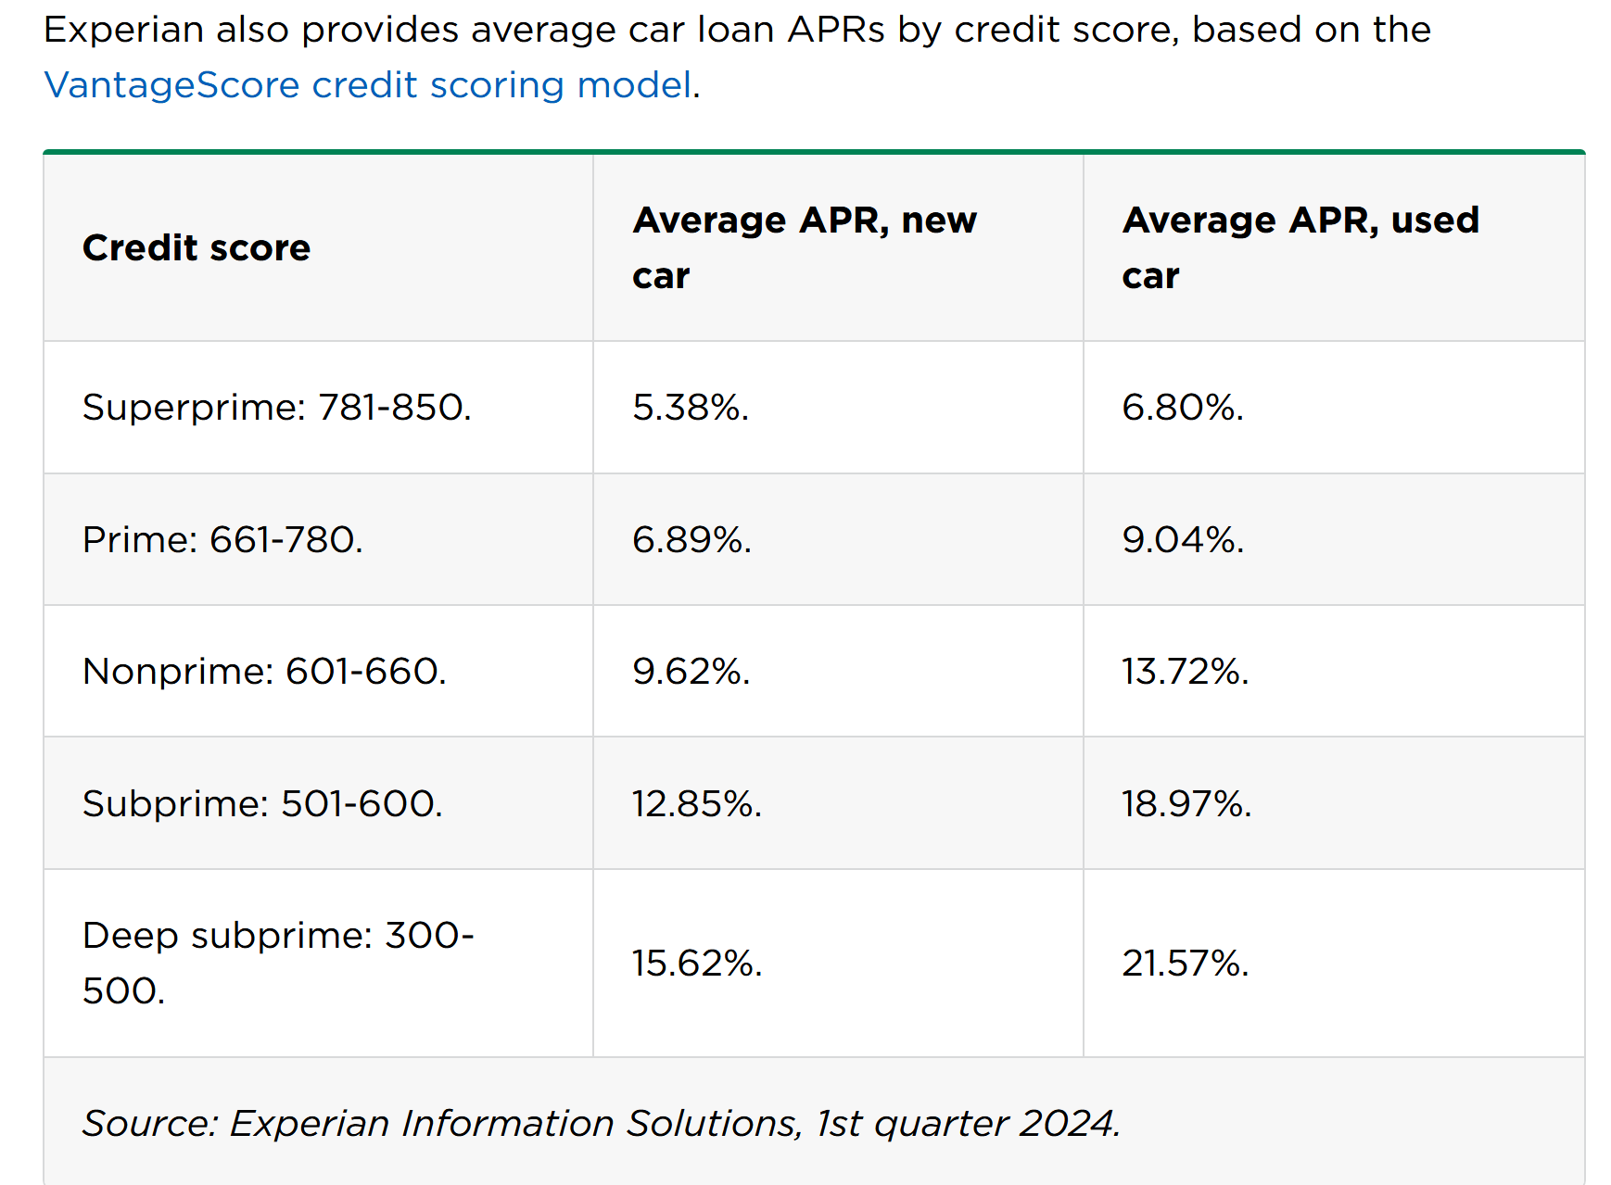
- Compare someone with a score of 800 to someone with a score of 500. What is the difference in interest rate they would pay, on average, for a loan on a new car?

Example: Look at how the difference in interest rate affects the finances of the loan:
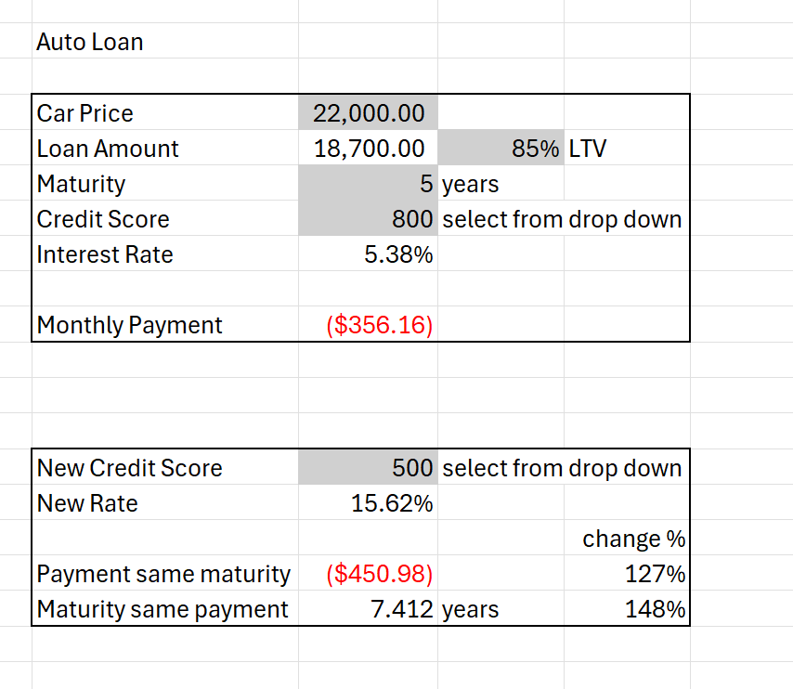
- How much more do you pay per month if the interest rate goes from 5.38% to 15.62% but the term and value of the loan remain the same?

Spreadsheet Connection
Use the sheet “T1 Auto Loan Payments” to answer the following questions:
- If someone is purchasing a new car for $50,000 with an 85% LTV ratio, a five-year term and they have a credit score of 720, how much will they pay per month?

- If someone else takes out a loan on the same terms, but has a credit score of 580, how much more will they pay per month? How much more will they pay over the entire repayment schedule?

- If someone is purchasing a used car for $25,000 with an 80% LTV ratio, a five-year term and they have a credit score of 500, how much will they pay per month?

- If someone else takes out a loan on the same terms, but has a credit score of 800, how much less will they pay per month? How much less will they pay over the entire repayment schedule?

Where do Credit Scores Come From?
People don’t have a single credit score, they in fact have multiple scores. This can seem confusing until you understand the process by which these scores are produced. You’ve probably heard of a lot of different companies and jargon related to credit scores. Here’s a brief overview of how it fits together. (Don’t worry about trying to remember it all now, we’ll return to key components later in the unit.)
- Lenders send information to Nationwide Credit Reporting Agencies (NCRAs), also called Credit Bureaus, (Equifax, Experian and TransUnion)
- Credit Buraus store that data in a credit file
- They use this data to produce reports of that data to be sent to lenders when you seek to borrow money or open a credit card.
- Credit Scores are calculated by the Credit Reporting Agencies using models developed by FICO and Vantage Score.
- In this way you can have different credit scores depending on which agency and which model is used.

Figure 1 | Figure 2
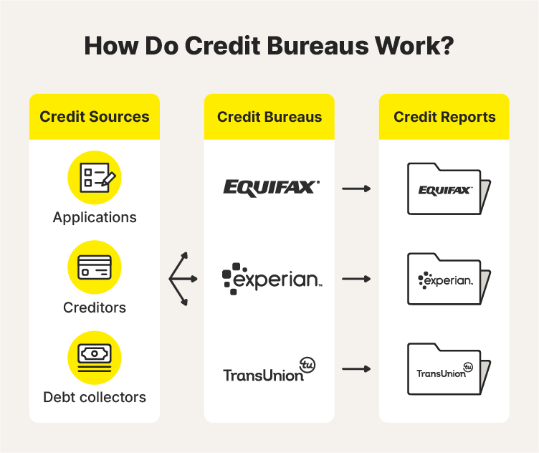

In this Unit we will learn about the data in credit files, what information is in a credit report and the mathematics underlying the models that are used to calculate Credit Scores.
Understanding this process will help you to manage your credit and improve your financial opportunities.


Topic 1: Check for Understanding
- A credit score is:
  - A list of everything you have bought online
  - A three-digit number that models how likely you are to repay debts on time
  - A number that shows how much money you have in the bank
  - Your income from your job

- If you have a higher credit score, this usually means:
  - You pay higher interest rates
  - You pay lower interest rates
  - You cannot get loans
  - You owe more in taxes

- Credit scores are most often used by:
  - Doctor’s Offices, Hospitals, and Dentists
  - Insurance companies, mortgage lenders, and credit card companies
  - Movie theaters, Theaters, and Music Venues
  - Public schools, Universities and Colleges

- (Select all that apply) A person with a low credit score is more likely to:
  - Receive the best loan terms
  - Be refused for a loan or charged higher interest
  - Get a higher credit limit
  - Pay less per month

- (Select all that apply) Why do lenders care about credit scores?
  - It tells them which customers are most likely to complain
  - It tells them the probability that a loan to that customer will be repaid
  - It helps them decide what interest rate to charge on a loan
  - It tells them how much tax they will have to pay on loan repayments

- If Mary has a credit score of 750 and James has a credit score of 600, what can we say about the two:
  - Mary is more polite than James
  - Mary earns more money than James
  - According to a mathematical model, the probability of making on time payments for a loan is higher for Mary than for James
  - Mary has a bigger appetite than James

Topic 2: Components of Credit Scores—Consumer Perspective
A credit score is usually a number between 300 and 850 (though some scores for specific purposes range between 250 and 900). The higher score, the better. A credit score above 670 is considered “good”, scores above 740 is considered “very good”, and scores above 800 or higher are regarded as ‘excellent’ – the highest teir in the range. The FICO credit score model calculates this number by looking at five kinds of information (Vantage credit score model uses similar but slightly different metrics):
- Payment history
  - This is your track record of making payments on time or failing to do so.
  - A longer payment history improves your credit score, provided the payments aren’t late.
- Amounts owed:
  - This is the amount of money you currently owe, taking into account all the different places you owe money and how much more credit you have available.
  - Owing lots of money to a range of sources lowers your credit score, as does approaching your credit limit.
- Length of credit history:
  - This is how long you have been making payments.
  - Starting a credit history earlier will improve your credit score in the long run, provided you are able to make payments on time.
- Credit mix:
  - The different types of credit accounts you have.
  - Having different kinds of credit available (e.g., mortgage, car loan, and credit card) improves your credit score – having many different credit cards will not improve your score.
- New credit:
  - This is how much credit you recently received or requested.
  - Applying for a lot of new credit all at once will lower your credit score.
  - Note that this includes signing up for multiple credit cards at once.
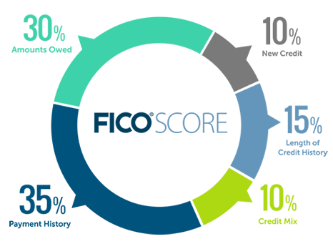
The relative importance of each of these categories is shown in this diagram from FICO (https://www.myfico.com/).

Some things an individual can do to maintain and cultivate a good credit score are:
- Make all loan payments on time.
- Keep down the amount you owe – in particular, pay off any credit card debt.
- If they don’t yet have any credit history, sign up for a credit card or other product that will start to build up the length of their credit history. If they have a credit card, make some purchases with it and pay the full balance each month. (Note: Paying the minimum balance is sufficient to build good credit, but paying off the full balance is a good idea for general financial well-being).
A few notes on this:
- If you are struggling to qualify for a credit card, there are options available to get your credit history started, such as a “pre-paid card” or getting a joint card with a guarantor.
- Payment of bills, rent, and some “Buy Now Pay Later” products do not affect your credit score (positively or negatively) unless they are sent to a collection service.
- Being charged interest on a credit card does not necessarily affect your credit score, as long as you keep up with minimum payments. However, that doesn’t mean it is not a problem as it can be a significant expense.
- You should be suspicious if anyone is ever trying to sell you a financial product whose explicit aim is to improve your credit score.

There is no single credit score that defines a consumer.
There are several credit scores in use. Scores from FICO and Vantage Score are produce by the credit bureaus (Experian, Equifax, Trans Union) using the FICO or Vantage Score models. These scores are widely used and consumers generally can see those scores when they learn about their credit score. FICO and Vantage Score have several versions of their models and the score for an individual consumer can vary significantly depending on which bureau and which model is used to perform the calculation. In addition, banks and other financial institutions may compute their own scores to assist in their lending and marketing practices – though these scores generally are not available to consumers.
What does it mean to make timely payments? What is delinquency?
When you take out a loan, you will often be required to make monthly payments, in order to repay the money borrowed, plus interest, over an agreed upon period of time.
- Those payments generally have a due date during the month. For example, most mortgage payments are due on the first of the month.
- Other payments could be due on any day during the month.
- Payments that are not made on time are delinquent.
Delinquency – Failure to make owed payments or failure to pay an outstanding debt.
Often there are financial consequences to making delinquent (late) payments. This could include additional fees or an increase in borrower’s rate.
Some lenders offer a grace period where payments, although late, do not lead to any consequences.
- If the terms of a loan offer a 30-day grace period, then even if you miss a payment date, if you make the payment within 30 days of when it was due, you will not face any penalty.
In addition, when payments are more than 30 days delinquent the lender may report the delinquency to a credit bureau.
- Such reporting may have an adverse impact on a borrower’s credit score.
- Payments that are two months later are generally referred to as 60 days delinquent, three months late as 90 days delinquent, etc.
Another term often used is default. From a legal perspective any failure to pay on time is considered a default. However, in practical terms the term default is usually reserved for when the lender seeks to recover the full amount of the loan after non-payment, not just for a payment that is late.
Activity: Go through each of these situations and discuss how they might affect the probability of making future payments.

- For each situation below, decide if the situation described makes a person more likely, less likely or it makes no difference to their likelihood of making future payments on time:
  - They have made a higher proportion of past payments on time
  - Their current debt is a higher proportion of their total available credit (e.g. they owe $4500 on the credit card, which has a limit of $5000)
  - They have a longer credit history (e.g., there is a record of them making credit card payments for over 20 years)
  - They have recently taken out a number of new lines of credit (e.g., in the past month they signed up for three new credit cards)
  - They have a more diverse mix of sources of credit
Situation | Relationship with future on time payments | Possible Reasons Why
a. | More Likely/Less Likely/No Difference
b. | More Likely/Less Likely/No Difference
c. | More Likely/Less Likely/No Difference
d. | More Likely/Less Likely/No Difference
e. | More Likely/Less Likely/No Difference


Topic 2: Check for Understanding
Directions: Use the word bank to fill in the blanks on the credit score info sheet (some words may be used more than once):
[Word Bank: in person, height, lowers, on time, raises, make payments, 1080, longer, earlier, not improve, shorter, credit score, FICO, dance, Geico, loan, 720, higher, owe, own, limit, lower]
- Practically speaking, you need to consider your credit score if you are hoping to take out a _________________.

- A credit score is a tool used by lenders to assess the risk that a customer will be unable to __________________________ on time. A good credit score provides 3 key benefits:
- It allows you to get a ______________ faster.
- It gives you a better rate of credit (you can get loans at a ____________ interest rate).
- It gives you access to more credit (many kinds of loans require a minimum _______________________ to be granted at all).

- The most commonly used credit score is the ______________ score. It is a number between 300 and 850; the higher the better (generally, scores above ___________ are regarded as ‘good’ scores). This number is calculated by looking at five kinds of information.

- Payment history: This is your track record of making payments on time, or failing to.
A _______________ payment history improves your credit score, provided the payments aren’t late.

- Amounts owed: This is the amount of money you currently owe.
Owing lots of money to a range of sources _______________ your credit score, as does approaching your credit ________________.

- Length of credit history: This is how long you have been making payments.
Starting a credit history_________________, provided you are in a position to make payments on time, will improve your credit score in the long run.

- Credit mix: The different types of credit accounts you have.
Having different kinds of credit available (e.g., mortgage, car loan, and credit card) ___________ your credit score – having many different credit cards will _____________ your score.

- New credit: This is how much credit you received or requested recently.
Applying for a lot of new credit all of a sudden will _____________ your credit score.

- The two crucial things you can do to maintain a good credit score are:
Make all payments ________________________ – both for bills and loan repayments.
Keep down how much you _____________ – in particular, have excess credit available.

- FICO scores usually range from:
  - 300 to 850
  - 600 to 700
  - 400 to 700
  - 300 to 800

- Which of the following does a good credit score NOT provide?
- A better rate of credit
- Access to credit faster
- Access to more kinds of credit
- Access to loans that you do not have to repay

- Explain why a landlord might be interested in a potential tenant’s credit score.

- For each of the following, decide how the action in the left column affects your credit score. Circle the correct option in the right-hand column:
Routinely paying at least the minimum payment on your credit card balance at the end of each month | Increase / Decrease / No Effect
Being late on a utility payment | Increase / Decrease / No Effect
Wearing a nice suit | Increase / Decrease / No Effect
Maintaining a line of credit for a long period of time | Increase / Decrease / No Effect
Opening 10 credit cards all at once | Increase / Decrease / No Effect
Taking out a mortgage | Increase / Decrease / No Effect
Approaching your credit limit | Increase / Decrease / No Effect
Keeping a lot of cash in your wallet at all times | Increase / Decrease / No Effect
Having a large amount of credit available | Increase / Decrease / No Effect
Writing checks rather than using a debit card | Increase / Decrease / No Effect

Topic 3: Consumer Behavior, Correlations and Credit Scores
If a person fails to keep up with their payments, it’s likely they are dealing with challenges managing resources. There could be many reasons for this:
- Change in life/employment: If an individual loses their job or is in a position where they cannot find work.
- Medical issues: If an individual suffers a long-term illness or has a serious accident that may prevent them from working
- Costly life events: If an individual has a divorce or needs to support a family member.
- Non-disciplined financial management: If an individual fails to plan or be attentive to their finances.
- Lack of matching between timing of income and expense: Sometimes cashflows do not line up and an individual may find they have future expected income but bills due now.
Any of these challenges could lead to behaviors we discussed above: Missing past payments (#1), approaching credit limit (#2), or taking out a lot of new credit (#4).
As challenges begin to mount, a consumer may increase their credit spending or take out additional sources of credit to buy themselves some time. They also may end up missing payments.
From the lender’s perspective, the fact someone has missed past payments, is close to their credit limit or has taken out new credit is an indication that they may be facing the kinds of challenges that make them likely to miss future payments.
- Having overdue payments and limited credit available means a consumer has less flexibility to deal with any additional financial problems that arise, again creating risk for future payments.
- For these reasons, these factors tend to lower a credit score.
Note that some of these challenges are temporary. Unfortunately, even if you have resolved them this may not be positively reflected in your credit score right away.
- You may have been unemployed for a month and had to increase your credit card spending, but now you have a job with a steady income.
- You may have dealt with a medical issue but now you are recovered.
- You may have previously struggled with financial management, but you have taken a course in personal finance and are now on top of things.
It’s important to keep in mind that credit scores are statistical indicators based on certain past records and do not necessarily reflect a person’s present capacity to handle credit.
Another issue is the quality of the evidence available to the lender when making decisions. If a person has no credit history, then, as a lender, you know nothing about them. Lending them money would be a complete shot in the dark, which would obviously be very risky.
- The longer a person’s credit history, the more evidence there is to go on about their future behavior.
- Similarly, a greater credit mix improves the quality of evidence. People may behave in different ways depending on the circumstances, and seeing how they make repayments with a range of loan types provides better evidence about future behavior.
These factors especially are not directly related to how you as an individual consumer are likely to manage your finances; instead, they are matter of what evidence a lender has available to distinguish you from a member of the population chosen at random.
Recall the five factors that go into a credit score:
- Payment History: How many of a person’s previous credit payments have been late or delinquent? What proportion of the total is it?
- Amounts owed: How much money do they currently owe? What proportion of their available credit is this?
- Length of credit history: How long has a person been making credit payments?
- New credit: How much credit has a person requested recently?
- Credit mix: How diverse are a person’s sources of credit? (How many do they have out of things like credit cards, auto loan, mortgage etc.?)


- Fill out the table below as follows:
- In the column labeled risk: Circle Increases if the situation increases the risk of future delinquency; Decreases if the situation decreases the risk of future delinquency; No Effect, if the situation has no effect on the risk of future delinquency.
- In remaining columns, choose which of the credit score factors are affected by the situation. For each column, put a plus (+) in the box if that’s the reason you think the situation positively affects one’s credit, put a negative (–) in the box if you think the situation negatively affect’s one’s credit. If the situation does not affect one’s credit, put an ex (×) under Not a Factor in CS.
- Note just because a situation influences one’s risk of future delinquency does not necessarily mean it influences one’s credit score, and vice-versa.
Situation | Risk of Future Delinquencies  (Circle one) | Payment History | Amount Owed | Credit History Length | New Credit | Credit Mix | Not a Factor in CS
- Never had a credit card or loan. | Increases  Decreases  No Effect
- Has had a bank account and a credit card for a decade and always makes payments on time. | Increases  Decreases  No Effect
- Always has back up cash for emergencies. | Increases  Decreases  No Effect
- Has been making student loan payments for 3 years. | Increases  Decreases  No Effect
- Always late on utility payments | Increases  Decreases  No Effect
- Uses lots of credit and always pays it off. Has lots of credit available | Increases  Decreases  No Effect
- Recently opened five new credit cards. | Increases  Decreases  No Effect

Credit Scores and Correlation
Now let’s look at some data related to credit scores to help us better understand them:
This chart compares credit score and credit utilization.
- Note that credit utilization may exceed 100%: for example, a person may overdraw their accounts, accrue interest that takes them over their limit or have their credit limit lowered below the current balance.

This is a scatter plot taken from real credit bureau data.
- Each point on the chart represents an individual consumer
- The x-value represents their credit utilization percentage, while the y-value represents their credit score.
- For example, a consumer with utilization of 75% and a credit score of 650 would correspond to a point at (75,650). Locate that person on the graph by finding point (75,650).

- What does this chart suggest about the relationship between credit utilization and credit score?
- What is the direction of correlation?
- How strong is the correlation?
- Does this agree with our theoretical discussion above?

A negative correlation tells us that if credit utilization increases, credit score tends to decrease. In order to be more precise about this relationship we need to find a line of best fit (or a trendline):

This chart displays the same scatter plot as before, but this time includes the line of best fit.
- We can use this graphically to estimate predicted values or use the formula to calculate it precisely

Example: If we want to predict the credit score of someone who has credit utilization of 90% we could either look at the y-value for the line where the x-value is 90% or we could plug 0.9 into the formula $y=-176.22x+756.56$
- What would you predict the credit score is for someone with 23% credit utilization?

- What would you predict the credit score is for someone with 140% credit utilization?

Consider the following chart, this compares credit score with “prior delinquency percentage” – the percentage of a consumer’s past loans that at one point were delinquent.

- What is the correlation implied by the graph? How does prior delinquency rate correlate to credit score?

- Does this fit with your prior expectations?

- Do you notice anything unusual about the pattern? Are the results distributed evenly across the x-axis? How would you interpret this pattern?

We see that there are a great number of datapoints with an x-value of zero, which tells us that many consumers have never had a delinquent account.
- We also see that that the y-values for these data points vary considerably.
- This means that the “prior delinquency %” variable is not telling us the whole story about credit scores.
- This makes sense as some people have no prior delinquencies because they have very little past credit behaviors so haven’t had an opportunity to let a loan become delinquent, while others have a long credit history of on time payments – these are very different credit profiles.
- If we run a linear regression between these variables, the R^2 value is only 0.13, this tells us that a model using this variable by itself doesn’t explain credit scores.
We may want to improve our model by adding an additional variable. Let consider two options:
  - Percent of current loans in good standing
  - Length of credit history

This chart compares percentage of loans in good standing with prior delinquencies. In order to show where multiple datapoints have the same value, we have made the points on the scatterplot transparent. If there are many overlapping datapoints, the plot on the chart will be darker.
- We see that the point at (1,0) is very dark, meaning that a lot of consumers have 100% of the current loans in good standing and a 0% prior delinquency rate.
- In fact around 40% of the dataset belong at (1,0)
- This suggests that adding good standing as another variable may not be best suited to explaining variation amongst those with 0 prior delinquencies.
Now consider this additional plot, comparing length of credit history with prior delinquency %:

Here we see that those with prior delinquency of 0 are somewhat evenly distributed across the x-axis. This suggests that adding credit age as another variable may help with explaining variation amongst those with 0 prior delinquencies.
If we use these variables in a linear regression, we get the following model:
$$Credit Score=652+3.8•Age-187•Prior$$

Example: If you have a credit age of 30 and a prior delinquency percentage of 5%, your predicted credit score is $652+3.8•30-187•0.05=757$
- What is your predicted credit score if you have a credit age of 10 years and a delinquency percentage of 60%?

- What is your predicted credit score if you have a credit age of 0 years and a delinquency percentage of 0%?

- Based on your knowledge of credit scores, do you think your answer to question 5 is a reliable prediction?

Additional Notes:
- Delinquency and even bankruptcy data is generally removed from the credit file after 6 to 10 years. So even for someone with a 20-year credit history, the delinquency percentage only applies to payments due in the last ~10 years.

- If someone’s credit file contains very limited data or no data at all, they will not be given a credit score, rather than having a low credit score.

Spreadsheet Connection: T3 Credit Score Correlations
Create your own scatter plots, lines of best fit, and regression analysis with “T3 Credit Score Correlations.”

Topic 3 Check for Understanding
Section 1
Consider this list of these characteristics that impact a consumer’s credit score:
- Payment history: How many of a person’s previous credit payments have been late or delinquent? What proportion of the total is it?
- Amounts owed: How much money do they currently owe? What proportion of their available credit is this?
- Length of credit history: How long has a person been making credit payments?
- New credit: How much credit has a person requested recently?
- Credit mix: How diverse are a person’s sources of credit? (How many do they have out of things like credit cards, auto loan, mortgage etc.?)

- Which of these characteristics may indicate a person is experiencing financial problems affecting their ability to make future payments?

- Which of these determine the quality and detail of evidence regarding the consumer that is available to lenders?

- List three difficulties a person may encounter that may influence the characteristics listed in question 1.

- For each difficulty you gave, explain how it may have been resolved so that it no longer impacts a person’s ability to make future payments, even if that doesn’t yet show up on their credit score.

- From a lender's perspective, why might they be cautious about lending to someone with a limited credit history, even though they have no direct evidence this person is unlikely to make future payments?

Section 2

- What does this chart suggest about the relationship between credit age and credit score?
- What is the direction of correlation?

- How strong is the correlation?

- Does this agree with our theoretical discussion above?

- Sketch a line of best fit on the chart
- Based on your line of best fit, what do you predict as the credit score for someone with a 15-year credit history?

- A multivariable regression model for credit scores provides the following equation:
$$Credit Score=583+168•\% Loans Good Standing-48.7•Credit Utilization$$
- What is the predicted credit score for someone with 80% of their loans in good standing and 15% credit utilization?

- What is the predicted credit score for someone with 25% of their loans in good standing and 93% credit utilization?

- What is the maximum credit score that can be predicted by this model?

Topic 4: What is a Credit Report?
Credit Bureaus and Credit Files
Where does the data that is used to create credit scores come from? The companies creating credit scores receive something called a credit file.
A credit file is data collected by a Credit Reporting Agency (also known as Credit Bureaus).
- A credit score is a numerical summary of data in a credit file.
- Credit Bureaus use the credit file to create a Credit Report.
- You can see a snapshot of a Credit Report in the image below
- See the sample Credit Report from Experian for more details [link]
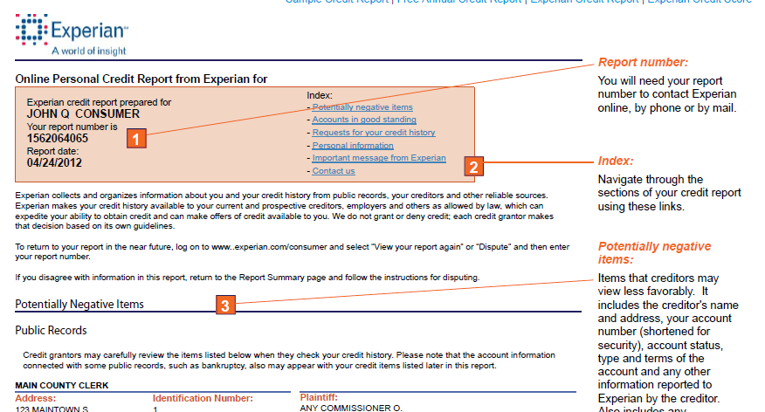
There are three primary Credit Bureaus: Experian, Equifax and Trans Union.
They operate according to the rules of the Fair Credit Reporting Act:
According to Experian: The Fair Credit Reporting Act (FCRA) is a federal law that helps to ensure the accuracy, fairness and privacy of the information in consumer credit bureau files. The law regulates the way credit reporting agencies can collect, access, use and share the data they collect in your consumer reports. [For further information, see What Is the Fair Credit Reporting Act?]
Analyzing credit files
The information in a credit file is stored in a database. You can see an example of how credit file information for a single customer file is stored in the table below.
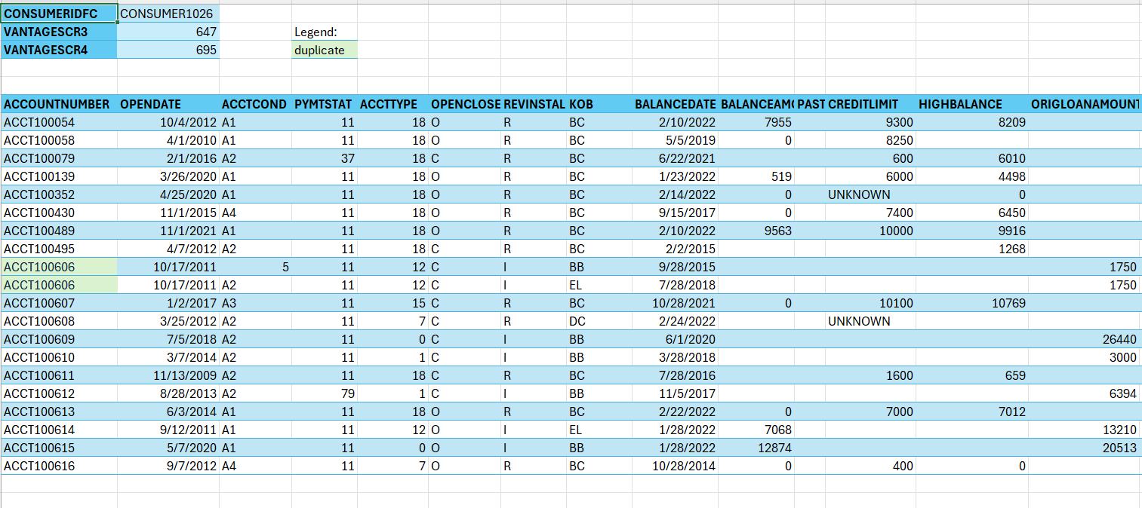
In this table information about each different line of credit or financial transaction is on a separate line.
- One line might represent a credit card the consumer uses and another an auto loan they have taken out.
- The data summarizes when the account was opened, its current and past payment status as well as a description of the type of loan.
- The file contains both open and closed accounts. Note a credit card remains open so that a person can make payments with it until either the user or the bank decides to close it. A loan like a mortgage or auto loan is closed once the amount borrowed has been repaid in full.
Example: The first line of the table provides information on Account Number 100054
- This account was opened on 10/4/2012
- In the open/closed column we have “O”, which mean the account is still “open”
- The balance amount column has the value “7955”, which is the amount in dollars that needs to be repaid.
- When was account 100079 opened?

- Is account 100079 open or closed?
As you can see there is a lot of information and codes to unpack in a credit file!
- In our regression models for credit scores above, we relied on only a handful of variables for each consumer, summarizing their activity across all accounts.
- It takes quite a lot of work to pull these summary variables from the datafile, we’ll take a look now at how this process works.
- Before we get to working with real credit files though, we’ll need to look at a simpler example first.

Spreadsheet Connection: T4A Fruitstand
The spreadsheet “T4A Fruitstand” provides training in working with a data file in Excel.
- The exercise asks you to help Alex, a fruit vendor, analyze sales to their top customers.
After working through the spreadsheet, answer the following questions:
- How many pounds of fruit did Alex sell to their favorite customers?

- Which customer spent the most money?

- Which product produced the most revenue?

- Which product sold the most pounds?

- What do you recommend Alex do in the future to make it easier to analyze?

Spreadsheet Connection: T4b Credit Data Functions
Complete “T4b Credit Data Functions” To learn about some useful functions for analyzing credit data. Next, look at “T4c Credit Data Single Consumer”, which contains the credit file of a single consumer. Before completing the questions on “T4c Credit Data Single Consumer,” use the informational sheets to answer the following questions:
- What does it mean if a row has the value “O” in the OPENCLOSED column?

- What does it mean if a row has the value “11” in column D?

- What would finding the maximum value in column B tell you?

- Which columns tell you about an account’s balance and credit limit respectively?

- What entry would tell you that an account is a credit card? Specify the column and value.


Spreadsheet Connection: T4c Credit Data Single Consumer

Now complete the questions on “T4c Credit Data Single Consumer”, and then consider the following questions:
Consumer1026 has a VantageScore4 of 695.
- What past actions may have lowered their credit score?

- What future actions might raise their credit score?

- What future actions might lower their credit score?

What’s Not in the Credit File?
Credit files can only contain information that is reported to credit reporting agencies. It does not contain any information about the consumer’s income, expenses or investments. Information about rent payment and certain utilities, such as phone payments, is frequently not in a credit file. Buy Now Pay Later transactions are also mostly not included in a credit file. Lenders may take information about these other items into account when deciding whether to offer credit to customers.
When entering into a large transaction, or if your credit score is lower than you expect, you may want to examine your credit file. You can request copies directly from the credit bureaus. They also have mechanisms for you to challenge information that you do not believe is correct. For information on how to do this, see https://www.consumerfinance.gov/ask-cfpb/how-do-i-dispute-an-error-on-my-credit-report-en-314/

Topic 4 Check for Understanding

Section 1
- Where do companies get the data that is used to create credit scores?
  - Looking on social media
  - Checking for neighborhood gossip
  - A person’s credit file
  - Asking a fortune teller
- The data included in credit files is regulated by the Fair Credit Reporting Act (FCRA). This aims to ensure credit files meet which criteria? (Select all that apply)
  - Data is accurate
  - Data reflects well on the consumer
  - Data is fair
  - Data is nicely formatted
  - Data preserves consumer privacy
- Which of the following appear on your credit file? (Select all that apply)
  - Credit card activity
  - Wages
  - Rent payments
  - Mortgage payments
  - Stock market portfolio
- What can you do if you believe there is an error in your credit report?
  - Write a letter to your boss or Human Resources Department?
  - Dispute the item with the credit reporting company
  - There’s nothing you can do

Section 2
- Use the description sheets in “T4c Credit Data Single Consumer” to answer the following questions:
  - What does it mean if a row has the value “C” in the OPENCLOSED column?

  - What does it mean if a row has the value “78” in column D?

  - What would finding the maximum value in column B tell you?

  - How do you find out if an account has zero balance? Specify the column and value.

  - What entry would tell you that an account is an auto loan? Specify the column and value.


- Complete the spreadsheet “T4 Check for Understanding.”

Topic 5: Credit Files to Attributes
How do we get from a credit file to a credit score? We discussed above how there were a few summary variables associated with each consumer that were plausibly correlated with their likelihood of delinquency, and we confirmed that they were correlated with their credit score.
- These are things like credit age and percentage of loans in good standing
We call these attributes. According to Experian, “attributes represent a description of the relationship between different data points that can be used to assess credit risk. Each individual data point provides a limited amount of information on credit behavior but not the full story – for that bigger picture – they need to be aggregated and combined.” https://experianacademy.com/blog/2024/07/30/how-attributes-improve-credit-decisioning/
This means that an intermediate step in creating a credit score is creating attributes from credit files.
This is a common general feature of data analysis.
- You initially receive the data in a messy form with a lot of information, not all of it relevant.
- Before conducting your analysis, you have to rearrange the data and create a few key attributes that will be useful for your purposes.
Before getting to how attributes are created in credit score models we will create a couple of introductory examples.

Spreadsheet Connection: Attributes NBA
For an introduction to creating attributes in spreadsheets see “Attributes NBA” sheet.

Example: A popular new type of VR glasses has been released. Unfortunately, these devices often break so people want to purchase insurance.
- We’re going to look at how an insurance company might go about creating attributes to decide how much to charge for insurance.

Here’s a sample of the data, and you can see the full data in sheet “5A VR Glasses”
sale # | size | shape | status
1 | Small | Round | OK
2 | Large | Rectangle | OK
3 | Medium | Aviator | OK
4 | Large | Rectangle | broken
5 | Small | Aviator | OK
6 | Medium | Aviator | OK
7 | Medium | Rectangle | OK
8 | Small | Aviator | OK
9 | Small | Aviator | OK
10 | Small | Aviator | OK

We have information on whether the item breaks or is OK, as well as the size and the shape of the glasses.
The insurance company will have to pay the $100 repair cost for every one of their customers whose product breaks.
- They want to price their insurance so that they make a 10% profit – the amount they receive in insurance payments is 10% more than the amount they spend on repairs.
One approach would be to offer a single price for insurance. If 20% of glasses break, then for each customer, the average cost to the insurer is 0.2*100 $20. Therefore, to make a 10% profit, the insurer must charge 20*1.1 $22, so that they make on average $2 of profit per customer.
- How much should the insurer charge if 15% of glasses break and they want to make a 10% profit?

- How much should the insurer charge if 30% of glasses break and they want to make a 10% profit?

- How much should the insurer charge if 1% of glasses break and they want to make a 10% profit?
Another insurer might want to take size into account when pricing insurance. They include size as an attribute in their pricing model.
Using the same approach as above, if large glasses break 30% of the time and small glasses break 10% of the time, they would charge $33 to insure large glasses and $11 to insure small glasses.
- If medium glasses break 20% of the time, how much would they charge for medium glasses if they’d like to make a 10% profit?

- Assume 10% of small glasses, 20% of medium glasses and 30% of large glasses break. If each insurance company has 300 customers, divided evenly between all three sizes, how much money will they make?

- Suppose customers are choosing between insurance companies, and can pick one which charges different rates based on size and which offers all customers the same rate. Which one will customers with small glasses choose? Which company will customers with large glasses choose? What do you think this means for the business prospects of both companies?

Spreadsheet Connection: T5a VR Glasses by Attribute
Now look at the spreadsheet “T5a VR Glasses by Attribute” to make some calculations about these attributes with data.

Credit Data and Attributes
When we looked at a sheet containing data on a single consumer, we saw how much complex data was associated with them. We also saw how we could extract some useful attributes from this data such as number of accounts in good standing, or credit utilization.
- While conceptually straightforward, it took a little work to do in excel.
- For example, to calculate the number of accounts in good standing the consumer has, we write a formula that instructs excel to look at the “account condition” column, and then add up how many cells contain the “good standing” code.
In order to create a credit score model, we need to find a way to repeat this process for many consumers, so that we generate the required attributes for every consumer in our database.
- Again, this is conceptually straightforward, all we are doing is repeating a process we already understand.
- How to write the instructions for this in excel (or any other program, is a little more complicated though) as we can’t manually write out new formulas for each individual consumer – there are far too many for that to be feasible.

- Instead, we have to program excel to recognize which rows belong to each consumer, and then automatically calculate the attributes for each consumer in turn.

Spreadsheet Connection: T5b CS 20 20
Work through the spreadsheet “T5b CS 20_20.”
Quartiles
How do we decide whether the attributes we created are good ones?
- Our goal is to use them to predict whether consumers are likely to make future payments on time
- So before getting into the technical details of model construction, it’s good to take a look at how our attributes relate to future payment behavior
We have created a number of attributes and we want to test how much they can tell us about consumer delinquency:
- Age of credit history
- Number of open accounts
- Number of different account types.
What if we try plotting a scatterplot?

On the y-axis, value 1 represents that the customer became delinquent and 0 that they did not.
We can see that this chart is not very helpful because points can only take one of two values on the y-axis – it wouldn’t make much sense to draw a line of best fit on it.
Intuitively, we want to know whether the proportion of data points that are delinquents varies between higher and lower values for age.
We can do this using quartiles.
Quartiles are the cutoff points that divide a dataset up into four equally sized parts based on the value of a given variable.
- In our case, the variable in question is credit age, so the first quartile is the value for credit age that 25% of the data set is below and the rest is above, the second quartile is the cutoff point 50% of the data set is below and so on.
Example: If there are 100 people and the first person has 1 marble, the second person has two marbles…the one-hundredth person has 100 marbles, then the first quartile is 25 marbles, the second quartile is 50 marbles, the third quartile is 75 marbles and the fourth quartile is 100 marbles.
We can look at what proportion of consumers within each quartile with respect to credit age are delinquent. If there is a pattern, this suggest that the attribute is useful. Consider the data on these 40 consumers:
Quartile | Quartile Value | Bad | Good | Proportion Bad
1 | 12.1 | 8 | 2 | 0.8
2 | 17.3 | 5 | 5 | 0.5
3 | 23.6 | 3 | 7 | 0.3
4 | 43.0 | 4 | 6 | 0.4

Since we are looking at 40 consumers there are 10 consumers in each quartile. We see that those in the lower quartiles seem to be less likely to be delinquent than those in the higher quartiles which suggests our attributes is a useful one.

The chart helps us grasp the relationship – we see there is a general decrease in the proportion of goods as the quartiles increase
- Each of the following charts displays quartiles for sample attributes. Decide which would be useful for predicting delinquency. Explain your answers.

Spreadsheet Connection: T5c Quartiles
Explore the usefulness of other attributes by calculating quartiles in excel in “T5c Quartiles.”

Topic 5: Check for Understanding Spreadsheet
Complete the spreadsheet “T5 Check for Understanding.”

Topic 6: Credit Scores, Probability and Odds
We said earlier that credit scores represent the probability of delinquency on future payments. We’ve also seen some of the factors that can influence this probability, and how to construct them as attributes based on the data in a credit file.
Now we’re going to look at how to interpret the numerical values of credit scores more precisely.
Credit scores are often on a scale from 300 to 850. Higher scores generally indicate a higher likelihood of making timely payments.
Since credit scores are often on a scale from 300 to 850 they cannot simply be probabilities. Probabilities are numbers between zero and one.
Credit scoring companies generally describe credit scores as reflecting the logarithm of the odds of a consumer making timely payments during some period (relative to missing one or more payments during that period.)
This is not how we usually think of “likelihood” in terms of the probability of an event occurring. We can break it down into stages though:
- The relationship between probability and odds
- Applying a logarithmic function to the odds
[Definition] Odds are another way of representing likelihood:
$$o=\frac{p}{q}$$
o: Odds that event a occurs
p: Probability event a occurs
q: Probability event a does not occur.
Example: Suppose there is a 25% chance it rains tomorrow. The odds it rains are
$$o=\frac{P\left(It rains\right)}{P\left(It does not rain\right)}=\frac{0.25}{0.75}=\frac{1}{3}$$
- If there is a 10% chance it snows tomorrow and consequently, and a 90% chance it does not snow tomorrow, what are the odds that it snows?

- If there’s a 40% chance it’s cloudy tomorrow, what are the odds that it’s cloudy?

You will often see odds represented as a ratio between whole numbers, a:b. If the probability that an event occurs is $\frac{a}{n}$, then the probability that the event doesn’t occur is $\frac{n-a}{n}$
- The odds are therefore $\frac{\frac{a}{n}}{\frac{n-a}{n}}$
- We can see that the n’s in the denominator cancel out, giving us $\frac{a}{n-a}$
- If we define $b=n-a$, we get the odds as $\frac{a}{b}$
- Conventionally, when writing odds, we use a colin “:” to avoid confusing odds with fractions or division.
  - Example: If an event has a 3/10 probability, we can write the odds as 3:7

- Express the odds for an event with a 3/4 probability of occurring using the conventional notation (using a colin “:”).

- Express the odds for an event with a 9/17 probability of occurring using the conventional notation (using a colin “:”).

- Express the odds for an event with a 1/2 probability of occurring using the conventional notation (using a colin “:”).

Odds are very intuitive if we think of examples like marbles in a bag. If a bag contains 30 red marbles and 50 blue marbles, the odds of pulling out a red marble are 3:5, which is another way of saying “for every three marbles that are in the bag there are five blue marbles”.

It is also straightforward to calculate probability given the odds.
$$o=\frac{p}{q}$$ | The Definition of Odds
$$o=\frac{p}{1-p}$$ | Replace q with 1-p
$$\frac{1}{o}=\frac{1-p}{p}$$ | Invert both sides
$$\frac{1}{o}= \frac{1}{p}-1$$ | Distribute the p
Now we solve for p:
$$\frac{1}{p}=\frac{1}{o}+1$$ | Add 1 to both sides
$$\frac{1}{p}=\frac{o+1}{o}$$ | Distribute the o
$$p=\frac{o}{o+1}$$ | Invert both sides

Next, we will use this result:
$$p=\frac{o}{o+1}$$
Example: If the odds for an event are ½, the probability is $\frac{\frac{1}{2}}{\frac{1}{2}+1}=\frac{\frac{1}{2}}{\frac{3}{2}}=\frac{1}{3}$
- If the odds for Awesome Apples beating the Bogus Bannas in a local basketball game are 5/2, what is the probability the Apples beat the Bananas?

- If the odds that this winter is colder than normal is 2:3, what is the probability that this winter is colder than normal?

Spreadsheet Connection: T6a Odds and Probability
See “T6a Odds and Probability” for more practice switching between odds and probability.

Though odds and probability are mathematically closely related, one key difference is that odds can have values greater than 1. This happens whenever the probability is greater than ½.
Since $p=\frac{o}{o+1}$, whenever $p>\frac{1}{2}$, the numerator of the fraction will be greater than the denominator, so the odds (o) will be greater than 1.
- When will the odds be less than 1? Explain or show why.

There is no limit to how large the odds can be. Consider the probability of an event that 200:1 odds (or $\frac{200}{1}$ or 200):
$$p=\frac{o}{o+1}=\frac{200}{201}$$
We can do a quick check that this is a number between 0 and 1 to be sure it is a well-defined value for p.
- Can you find a value for p such that the odds are 10,000:1?

How Large Can the Odds Get?
For any positive number n, no matter how large, if we set $p=\frac{n}{n+1}$ , which is a well-defined value for p as it is between 0 and 1, we’ll get a value of n for the odds. This means that there is no limit to how large the odds can get.
- Is there a limit to how close to zero the odds can get? Explain your answer. Give an example.

On the other hand, the odds cannot be negative. For $p=\frac{o}{o+1}$to be negative, either p or 1-p would have to be negative. We know p has to be positive (or zero). For 1-p to be negative, p would have to be greater than 1, but this is not possible either. (For more information, see our blog on Odds vs. Probability.)
Credit scores don’t represent odds directly: they represent the logarithm of the odds. We’ll consider this graphically first. The chart below shows the relationship between odds of repayment and credit score, and we see that is an exponential curve.
- This means that a linear increase in credit score corresponds to an exponential increase in odds of on-time payment (i.e., not falling delinquent)
- For an approximately 50-point increase in credit score, the odds of on-time payment double

We can see that the odds of on time payment are approximately 50:1 for a credit score of 700, 100:1 for a score of 750 and 200:1 for a score of 790. Use the graph above to answer the questions below.
- Approximately what are the odds of on-time payment for someone with a credit score of 820?

- What is the probability of an on-time payment for someone with a credit score of 820?

- What is the approximate credit score for someone whose probability of making an on-time payment is 80%?

When we talk about the log odds of something occurring, all we mean is that we take the odds and apply a logarithmic function to it.
So, if the odds of repayment are 3, the log₂ odds of repayment are log₂(3)=1.58
- If the odds of repayment are 16, what are the log₂ odds of repayment?

- If the odds of repayment are 15, what are the log₂ odds of repayment?

- If the probability of repayment is 0.2, what are the log₂ odds of repayment?

- If the probability of repayment is 0.75, what are the ln odds of repayment?

We can confirm the logarithmic relationship between credit score and odds by taking the log₂ of the odds and plotting this on the y-axis.
We see here the linear relationship between log odds and credit score.
- When the score increases by 60 points, the log₂ odds increase by 1
How do we convert credit scores from log-odds, to odds and probability?
- The inverse of a logarithmic function is an exponential function
- If log₂(o) = x, then $o=2^{x}$
Example: On the chart, we can see that someone with a credit score around 570 has log₂ odds of defaulting of 2, if log₂(o)=2, $o=2^{2}=4$.
- Their odds of making an on time payment are 4:1
- They have an 80% probability of on time payments.
- Assume a person with a credit score of 760 has log₂ odds of 5. What are their odds and probability of making an on-time payment?

- What would log₂ odds of zero represent in terms of odds and probability of on-time payments?

- What would log₂ odds of -2 represent in terms of odds and probability of on-time payments?

Given this relationship, we can express credit score (S) as a linear function of log odds (l):
$$S=a+b•l$$
- If S increases by 60 when l increases by 1, what is the value of b.
(Hint: y = mx + b)

- Using a data point from the graph, estimate the value of a.

As we just saw, while odds can range in value between 0 and infinity, log-odds can take on negative values too! If we pick a random negative number, say -1000, we can find a probability that corresponds to log₂ odds of -1000.
- If log₂(o)= -1000, $o=2^{-1000}$ which is a very small positive number
- $p=\frac{2^{-1000}}{2^{-1000}+1}=\frac{{\frac{1}{2}}^{1000}}{{\frac{1}{2}}^{1000}+1}$ is a number between 0 and 1.

- For any n, show that there is a well-defined probability corresponding to log₂ odds of -n.

This is a useful feature for linear modeling purposes, since non-horizontal lines of best fit must always go below the x-axis at some point.
When interpreting credit scores, we can use the properties of logarithmic functions to help. We know that a linear change in a logarithm value, corresponds to an exponential change in its argument value.
- $y=\log_{2}\left(x\right)$, $y+n=\log_{2}\left(x\right)+n=\log_{2}\left(x\right)+\log_{2}\left(2^{n}\right)=\log_{2}\left(x•2^{n}\right)$
- In other words, when we increase the log₂ odds by n, the odds double n times

- If log₂ odds of repayment increase by 1 every time the credit score increases by 60, what happens to the odds of repayment when the credit score increases by 120?

- What happens to the odds of repayment when the credit score increases by 30?

It’s important to keep in mind that the relationship between odds and probability is not linear. In particular, as the log odds get large, and odds get even larger, big changes in odds can correspond to quite small changes in probability.
- For example, a jump in odds from 256:1 to 512:1 seems big, but it is equivalent to a change in probability from 99.6% to 99.8%
- This means that for higher credit scores, differences represent small distinctions in repayment likelihood. A jump in credit score from 500 to 600 represents a much bigger change in probability than from 750 to 850.
One reason credit scores are scaled like this is because a large proportion of the population has a very high probability of making repayments and lenders want to be able to distinguish between them.

We can see from this chart that most of the population has odds of on-time payment of 100:1 or above (that is, over 99% probability). If credit scores had a linear relationship with probability, then most of the population would have a virtually identical score, which would make it less useful for distinguishing borrowers.
Note that if there is a linear relationship between credit score and log₂ odds, there is a linear relationship between credit score and log odds of any basis. Suppose:
$$C=a+b•\log_{2}(o)$$
By the change of base rule for logs $\log_{2}\left(o\right)=\frac{\log_{n}\left(o\right)}{\log_{n}\left(2\right)}$ for any new base n
Since $\log_{n}\left(2\right)$ is a constant, we get
$$C=a+\frac{b}{\log_{n}\left(2\right)}•\log_{n}(o)$$
This is a formula for credit score as a linear function of log base n odds
- Using your answers to questions 15-16 above, express credit score as a linear function of log₁₀(odds).

- Using your answers to questions 15-16 above express credit score as a linear function of ln(odds).

We will take advantage of this, and move back and forth between different bases, as sometimes it is intuitively easier to us log₂ or log₁₀, while mathematically it’s easiest to use natural log.

Spreadsheet Connection: T6b Score, Odds and Probability
Calculate and graph the relationship between credit scores and log odds yourself on the sheet “T6B Score, Odds and Probability”


Extension
Credit scores are intended to rank borrowers – to say which borrowers are more likely to pay on-time than others. Actual credit performance can vary across time and financial products.
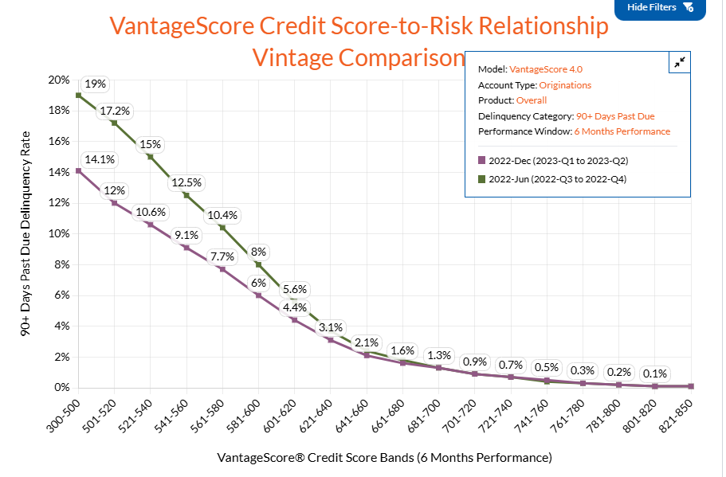
Example: If there is a recession, everyone will be more at risk of missing repayments. However, credit scores do not change along with the environment – instead the correspondence between credit score and probability of on-time payments shifts.
Chart shows comparison of delinquency rate for two different time periods for borrowers with the same VantageScore.

Topic 6: Check for Understanding
Use these questions to check that you understand the material from this topic.
- If there is a 90% chance it rains tomorrow, what are the odds that it rains?

- If there’s a 31% chance it’s windy tomorrow, what are the odds that it’s not windy?

- Express the odds for an event with a $\frac{11}{13}$ probability of occurring using the conventional notation.

- If the odds for an event are $\frac{4}{3}$, what is the probability?

- There is a bag full of black and white pebbles such that the odds of pulling out a while pebble are 2:1. We don’t know how many total pebbles are in there. You want to add black pebbles to the bag and I want to add white pebbles. How can we do so while ensuring the odds of pulling a white pebble remain unchanged.

- When will the odds equal 1? Explain your answer

- Can you find a value for p such that the odds are 1:10,000

- If the odds of repayment are 0.005, what are the log₂ odds of repayment?

- If the probability of repayment is 0.3, what are the ln odds of repayment?

- What would log₂ odds of 10 represent in terms of odds and probability of on-time payments?

- What would ln odds of -4 represent in terms of odds and probability of on-time payments?

- If ln odds of repayment increase by 1 every time the credit score increases by 75, what happens to the odds of repayment when the credit score decreases by 75?

- What happens to the odds of repayment when the credit score increases by 25?

Topic 7: Delinquency and Logistic Regression
The goal of credit scores is to predict how likely a consumer is to fall delinquent in the payments.
- We have seen how attributes can be constructed from credit reports and by breaking down outcomes by quartile, we’ve got some initial evidence that these attributes are related to likelihood of delinquency.
- However, our previous tool for constructing statistical models, linear regression, is not appropriate in this case.
- We saw that credit scores do not relate in a linear fashion to likelihood of delinquency but instead relate log odds.
In this topic, we’ll see how to put these ideas together, using logistic regression models (instead of linear ones).
Logistic models are used when we want to predict an outcome that can only take values 0 and 1.

In this chart we see the relationship between log odds and probability. As log-odds run from negative infinity to positive infinity, probability runs from 0 to 1 in an S-shaped curve.
- This means that if our model predicts linear values for log-odds, it will predict values between 0 and 1 for probability.
Example: You are driving to the airport. What is the relationship between the time you leave your home and the probability you arrive in time for your flight?
- The greater the amount of time you leave in advance, the higher the probability you make it on time.
- It’s plausible to think the relationship will be modeled by an S-curve like the one on the graph.
- Suppose the drive on average takes 120 minutes but varies due to traffic. If you set off exactly 120 minutes before you need to arrive, you’ll have about a 50% chance of making it in time.
- As you increase the time, the probability will get closer and closer to 1 while as you decrease the time, it will get closer and closer to zero.

This chart shows how the relationship might look.
- What is the approximate probability you would arrive on time if you departed 140 minutes in advance?

We get a curve of this form if we model log-odds of arrive on time as a linear function of departure time: $LN\left(odds\right)=a+b•d$, where a and b are constants, and d is departure time.
- Using the graph above, can you estimate values for a and b? Hint: Look at approximate values of log-odds for different probabilities, e.g. 0.5 and 0.1, in the first chart and compare with values for departure times on the second chart then solve the simultaneous equations.
We might get a similar chart if we compared, length of credit history with probability of on-time payments, though the relationship will be less neat than in this example, since many more factors go into loan repayment than driving time.
This shows what our model should look like, but how do we use data to create it?

Here we have a chart displaying data on whether a person arrived on time for various departures. These results can only take values 1 and zero. We can see that there are more 1s for high departure values and more 0s for lower values.
- We could try drawing various S-curves to model probability.

- Which line best models the data? Why?

Just like with lines of best fit in linear regression, we can see intuitively that some of these lines are better than others.
- The math of how this works is a little more complicated. It’s not simply that distance from the line is the error: since outcomes can only be 0 or 1, predicted probabilities in the middle will always be some distance away, but that doesn’t mean they are bad or incorrect.
- Instead, we want the proportion of 1s and 0s at any point along the curve to match the predicted probability.
- For example, for values of departure time where the predicted probability is approximately 0.5, we want around half of data points to be 0 and half 1
Logistic regression involves using a complex algorithm to calculate the curve that best fits with the data.
- It assumes there is a linear relationship between the input variable(s) and log-odds
- It tries out various values for linear coefficients and calculates the error for each combination
- It then selects the values which produce the lowest error

Predictions using a Logistic Model
Example: Suppose we created a model that gave us the following coefficients for log-odds:
$$LN\left( Odds \left(On Time\right)\right)=-3.7+0.03•(Depature Time)$$
From this we can predict the probability of being late based on departure time.
Let’s assume you are departing 160 minutes before the flight:
$$LN\left( Odds \left(On Time\right)\right)=-3.7+0.03•160$$
$$LN\left( Odds \left(On Time\right)\right)=1.1$$
$$Odds\left(On Time\right)=e^{1.1}$$
$$Odds(On Time)=3$$
Therefore, $P\left(On Time\right)=\frac{3}{3+1}=\frac{3}{4}$
- What is the probability you will be on time if you depart 80 minutes before the flight?

- Suppose you want to risk no more than a 20% chance of being late. How far in advance do you need to depart.

Just like with linear regression, we can use multiple variables in logistic regression to improve our models.
Example: When predicting whether we’ll be on time to their airport, we could add an additional variable for time stuck in heavy “rush hour” traffic (that we will call Rush).
- $LN\left( Odds \left(On Time\right)\right)=-4+0.03•Depature-0.01•Rush$
- So, if I depart 140 minutes before the fight and there is going to be 15 minutes of rush hour delays, $LN\left( Odds \left(Late\right)\right)=-4+0.03•140-0.01•15=0.05$
- Therefore, $P\left(On Time\right)=\frac{1}{1+ e^{-0.05}}=0.51$

- Using the same model as above, what is the probability of being on time for someone who departs 100 minutes in advance and is stuck in 30 minutes of heavy traffic?

Spreadsheet Connection: T7a Creating Logistic Models
Exploring creating your own logistic models in excel on “T7a Creating Logistic Models”
We can do use the same approach when predicting credit scores. The following chart shows a model predicting delinquency probability based on length of credit history (“Credit Age”)

The equation for our model is:
- $LN\left(Odds \left(Delinquent\right)\right)=0.5-0.09•Age$
Therefore, if someone has a credit age of 25 years, our model tells us they have a 10% chance of being delinquent:
- $LN\left(Odds \left(Delinquent\right)\right)=0.5-0.09•25=-2.25$
- $P\left(Delinquent\right)=\frac{1}{1+ e^{2.25}}=0.1$
- What is the probability of delinquency for someone with a 40-year credit history?

- What is the probability of delinquency for someone with a 15-year credit history?

- What is the probability of delinquency for someone with no credit history?

We might also create a more complex model using multiple variables: Percentage of loans in good standing (“Good”), Credit Utilization (“Utilization”), and length of credit history ("Age”), to get the following model.
- $LN\left( Odds \left(Delinquent\right)\right)=0.7-0.88•Good+0.29•Utilization- 0.1•Age$
Example: If a consumer had 75% of their loans in good standing, a 20% credit utilization and a 15-year credit history our model predicts they have a 20% chance of delinquency:
- $LN\left( Odds \left(Delinquent\right)\right)=0.7-0.88•0.75+0.29•0.2- 0.1•15=-1.4$
- $P\left(Delinquent\right)=\frac{1}{1+ e^{1.4}}=0.20$
- If a consumer had 20% of their loans in good standing, an 80% credit utilization and a 25-year credit history, what is their probability of delinquency according to the model?

Interpreting Logistic Models
We have a logistic model of the form $LN\left(odds\right)=a+bx$
- How do we interpret this?
- Like with any linear equation, a tells you the value of $LN(odds)$ when x is zero and b tells you how much the value of $LN(odds$) changes by when x increases by 1
- In our on-time model, b represents the change in $LN(odds(arriving on time))$ when departure time increases by one minute.
What does a change in log odds do to probability?
$Odds=e^{LN\left(Odds\right)}$ $Odds=e^{a+bx}$ ($LN\left(odds\right)=a+bx)$
So, when $x = 0$, $Odds=e^{a}$
What happens when x increases by one?
$$Odds=e^{a+b\left(x+1\right)}e^{a+bx+b}$$
$$Odds=e^{a+bx}e^{b}$$
Since, $e^{a+bx}$ are the odds for the original value of x, increasing x by 1 multiplies the odds by $e^{b}$.

Example: Recall our model using departure time: $LN\left(Odds \left(On Time\right)\right)=-3.7+0.03•Depature$
- Since b = 0.03, when you increase the departure time by 1 minute, the odds of being on time increase by a factor of $e^{0.03}=1.03$
We saw above that for a departure time of 160 minutes, $Odds(On Time)=e^{1.1}=3$
- Therefore, for a departure time of 161 minutes:
$$Odds\left(On Time\right)=3•e^{0.03}$$
$$Odds\left(On Time\right)=3•1.03$$
$$Odds\left(On Time\right)=3.09$$
- Recall, our logistic model using credit age, $LN\left(Odds \left(Delinquent\right)\right)=0.5-0.09•Age$
  - How does increasing credit age by one year affect the odds of delinquency?

  - We calculated above that the odds of delinquency for some with a 25-year credit history were 2.25. What are the odds of delinquency for someone with a 26-year credit history?

- Consider how the coefficient values in our models relate to the odds:
- If $b>0$, will $e^{b}$ be greater or less than 1?

- If a variable has a positive coefficient, will the value of that variable increase or decrease the odds?

- If a variable has a negative coefficient, will increasing the value of that variable increase or decrease the odds?

- Consider a multivariable logistic regression model
$$LN\left(Odds\right)=b_{0}+b_{1}x_{1}+b_{2}x_{2}…+b_{n}x_{n}$$
How will increasing the value of a single variable $x_{i}$ change the odds? Explain your answer.

Suppose p is probability and l is log odds: $p= \frac{1}{1+ e^{-l}}$
- So, in a logistic model, $p= \frac{1}{1+ e^{-\left(a+bx\right)}}$
- Therefore, when x is 0, $p= \frac{1}{1+ e^{-\left(a\right)}}$
- When we increase x by 1:
$$p= \frac{1}{1+ e^{-\left(a+b\left(x+1\right)\right)}}$$
$$p=\frac{1}{1+ e^{-\left(a+bx\right)}e^{b}}$$
- If b is greater than zero, what happens to p when x increases in value?

The effect of increasing x by 1 on p is not constant across all values of x.
Recall our model $LN\left(Odds \left(On Time\right)\right)=-3.7+0.03•Depature$
Consider a departure time of 120 minutes verses 130 minutes:
- If departure time is 120 minutes, $x=120; P\left(On time\right)=\frac{1}{1+ e^{-\left(-3.7+0.03*120\right)}}=0.48$
- If we increase departure time by ten minutes to 130 minutes, $x=130;$ $P\left(On time\right)=\frac{1}{1+ e^{-\left(-3.7+0.03*130\right)}}=0.55$
- On time probability increases by 7% when we leave 130 minutes instead of 120 minutes (120mins 0.48. 130mins 0.55)
Consider a departure time of 120 minutes verses 130 minutes:
- If departure time is 220 minutes, x = 220; $P\left(On time\right)=\frac{1}{1+ e^{-\left(-3.7+0.03*220\right)}}=0.95$
- If we increase departure time by ten minutes, x=320, $P\left(On time\right)=\frac{1}{1+ e^{-\left(-3.7+0.03*230\right)}}=0.96$
- On time probability increases by only 1% when we leave 230 minutes instead of 220 minutes (220mins 0.95. 230mins 0.96)
- Consider our model using credit age, $LN\left(Odds \left(Delinquent\right)\right)=0.5-0.09•Age$.
  - How does probability of delinquency change if you increase Age from 5 to 6?

  - How does probability of delinquency change if you increase Age from 40 to 41?

Creating a Credit Scores from Log-Odds
How do credit scores relate to the log-odds in our model?
From a mathematical perspective, we could just use log-odds prediction generated by a logistic model. However, these numbers are not very intuitive.
- They include negative values and fall within a fairly small range so that you need look at multiple decimal points to distinguish consumers.
- This can make them hard to interpret at a glance, especially for people without a deep mathematical background.
We come up with linear function for credit scores to make them easier to understand:
$$CS=a+b•LN(Odds)$$
The value of b tells you how much the score will change when the log-odds change.
- Suppose that we want the score to change and decrease by 40 when the odds double (recall that higher credit scores mean lower odds of delinquency).
- That way, we can round credit scores to the nearest whole number without missing significant information.
$$Odds=e^{LN\left(odds\right)}$$
We want to find how $LN(odds)$ change when odds are doubled:
$$2•Odds=2•e^{LN\left(odds\right)}$$
$$2•Odds=e^{LN\left(2\right)}e^{LN\left(odds\right)}$$
$$2•Odds=e^{LN\left(odds\right)+LN(2)}$$

Therefore, when $LN(Odds)$ increase by $LN(2)$, we want to set b so CS decreases by 40.
$$CS-40=a+b•\left(LN\left(Odds\right)+LN\left(2\right)\right)$$
$$CS-40=b•LN\left(Odds\right)+b•LN(2)$$

We can solve this system by subtracting $CS=a+b•LN\left(Odds\right)$:
$$CS-40-CS=a+b•\left(LN\left(Odds\right)+LN\left(2\right)\right)-(a+b•LN\left(Odds\right))$$
$$-40=a+b•LN\left(Odds\right)+b•LN(2)-(a+b•LN\left(Odds\right))$$
$$-40=(a+b•LN\left(Odds\right))-(a+b•LN\left(Odds\right))+b•LN(2)$$
$$-40=b•LN(2)$$
$$b=\frac{-40}{LN(2)}$$
Then we set a to value which ensures all results are positive and within the desired range.
- When $LN(Odds)=0$, $CS=a$ and $Odds=1$, so the value of a determines the credit score for someone who’s odds of delinquency are 1:1 – or a 50% probability.
- In line with conventional models, we choose a = 550 to represent a someone who’s odds of delinquency are 1:1 – or a 50% probability
Therefore, our formula for credit scores, based on our logistic regression model is:
$$CS=550-\frac{40}{LN\left(2\right)}•LN(Odds)$$
Example: If someone’s log-odds of delinquency is 1.5, then what is their credit score using our formula:
$$CS=550-\frac{40}{LN\left(2\right)}•LN(Odds)$$
$$CS=550-\frac{40}{LN\left(2\right)}•1.5$$
$$CS=463$$
- Using our formula above, what is the credit score for someone who’s log odds of delinquency are -2.3?

We could go further and plug in our logistic model using credit age $LN(Odds(Delinquency))$
$$LN\left( Odds \left(Delinquent\right)\right)=0.5-0.09•Age$$
$$CS=550-\frac{40}{LN\left(2\right)}•0.5-0.09•Age$$
We can plug this equation into a table using excel:
Credit Age | LN(Odds):  0.5-0.9*Age | Credit Score:  550-40*LN(Odds)/LN(2)
0 | 0.5 | 521
5 | 0.05 | 547
10 | -0.4 | 573
15 | -0.85 | 599
20 | -1.3 | 625
25 | -1.75 | 651
30 | -2.2 | 677
35 | -2.65 | 703
40 | -3.1 | 729
- Either on paper or in a spreadsheet: Create a table with credit scores in the left-hand column ranging from 530 to 750 in intervals of 20, with corresponding log odds and credit ages.

Spreadsheet Connection: T7b Create Credit Score Models
Use spreadsheets to create your own credit score in “T7b Create Credit Score Models.”

Topic 7: Check for Understanding
Use these questions to check that you understand the material from this topic.
- We want to predict how likely you are to get through check-in and security in time to board your flight based on how many minutes before departure time you arrive at the airport. We get the following logistic model:
$$LN\left(Odds \left(Board\right)\right)=-2+0.05•Arrive$$
- What is the probability you can board if you arrive 30 minutes before departure time?

- Suppose you want to risk no more than a 5% chance of being late. How far in advance do you need to arrive?

- What does the model say is the probability of boarding if you arrive 10 minutes after the departure time? Does this seem like a reasonable prediction?

- We come up with a model for predicting whether a consumer will be late on future payments, using variables: Percentage of loans in good standing (“Good”), Credit Utilization (“Utilization”), length of credit history ("Age”), percentage of prior loans that were delinquent (“DQ”):
$$LN\left(Odds \left(Delinquent\right)\right)=0.69-0.87•Good+0.29•Utilization- 0.1•Age+0.02•DQ$$
- A consumer has 95% of loans in good standing, a 20% credit utilization, a credit ages of 15 years and a 10% prior delinquency rate. What is the probability they will be late on future payments?

- According to this model, what is the probability of a person with no credit history at all being late on future payments?

- How does increasing credit utilization by 1% affect the odds of future late payment?

- Which out of increasing Good by 1%, increasing Utilization by 1% and increasing DQ by 1% will result in the biggest change in odd? Explain your answer.

- How much would you have to change the value of Age in order for the odds to double?

Now complete the sheet “T7 Check for Understanding.”

Topic 8: Evaluating Models and Creating a Credit Score
After creating a logistic model, how should we evaluate it? How do we know if it’s any good?
We can create a scatter plot comparing predicting values with actual outcomes, just like with linear regression.
- As we saw in the previous section, this is harder to evaluate visually than the distance of data points from a linear line of best fit.
There are many other options, some intuitive and some technical.
One method is to group our data in buckets by predicted probability, and see proportion of successful outcomes in each bucket. This chart does this for our airport model:

The columns tell us what proportion of flights were on time within each predicted probability range.
- For example, about 50% of departures that our model said had a 30-40% chance of arriving on time in fact arrived on time.
- Out of flights our model predicted had a 70-80% chance of arriving on time, around 80% in fact arrived on time.

- Out of those departures the model predicted had a 20-30% chance of arriving on time, how many in fact arrived on time?
The mid-point line shows roughly the results we’d get if our model perfectly matched our data. Out of those predicted to have between 20% and 30% probability of arriving on time, we’d hope on average 25% in fact arrive on time.
- This shows fewer people arrive on time than our model predicts in the 60-70%, while more do in the 30-40% range
- Still the general alignment between the actual results and the mid-point line suggest our model is working reasonably well.
Here is a chart looking at the model predicting delinquencies.

- What proportion of consumers who had a predicted delinquency probability between 20% and 30% were actually delinquent?

- Based on this chart, how would you evaluate the effectiveness of the model? What are its strengths and what are its weaknesses?

Using a Logistic Model to make Binary Predictions
We sometimes use a logistic model to make binary predictions. We do this whenever there are two outcomes and we are asking, “will the event happen or won’t it?” To do this, we decide on a cutoff point such that, if the probability is above that threshold, we predict the event will happen, and if the probability is below it, we predict it will not happen.
For example, we might say that if our model says there is an 80% chance of making a flight if we depart at a certain time, we predict that we will make it. So, when deciding when to depart, we use that 80% threshold as a guide.
- We can evaluate our model based on that prediction cutoff point using something called a confusion matrix. This compares predicted results with actual results
 | Late | On-Time
Predicted Late | 95 | 64
Predicted On-Time | 6 | 35

This confusion matrix for flights with the 80% cut-off lets us evaluate our prediction model.
- Each cell in the 2x2 grid counts the number of data points with the corresponding predicted and actual outcomes.
- The bottom right value tells us that for departures that were predicted to arrive on time, 35 did actually arrive on time.
- The bottom left value tells us that for departures that were predicted to arrive on time, 6 were in fact late.
- Therefore, if we had used this decision tool, to decide whether a departure time is safe, we would have arrived on time $\frac{35}{35+6}=85\%$ of the time.
- Of all the times when we predicted we would be late, how many times would we expect to arrive on time?

Suppose a lender only wants to make loans to people who our model says has a probability of delinquency below 20%. Here is the confusion matrix corresponding to this prediction threshold.
 | On Time | Delinquent
Predicted On Time | 645 | 35
Predicted Delinquent | 228 | 91

- Out of those we predicted would repay on time, how many would in fact be delinquent?

- What proportion of consumers the lender would choose to give a loan to based on this threshold would then end up being delinquent?

- What proportion of consumers who the lender would not make a loan to based on this threshold would then end up repaying that loan on time?

We can see from these questions the various trade-offs that come with using a model to make decisions.
- The confusion matrix shows that there are 228 consumers who are predicted delinquent but would in fact pay on time. These are lucrative loans that the lender is missing out on.
- The lender could raise their prediction threshold to 30% to try and capture more of these consumers, but this risk increasing the proportion of loan they make that fall delinquent.
Here is the confusion matrix for flight predictions if we lower the threshold for predicting on-time arrival from 80% to 60%.
 | Late | On-Time
Predicted Late | 86 | 44
Predicted On-Time | 15 | 55

The number of departures predicted as arriving on time that do in fact arrive on time has increased from 35 to 55, so the person using this method has increased their successful options.
- However, the proportion of predicting on time departures that arrive late is now $\frac{15}{15+55}=22\%$

Here is the confusion matrix for delinquency predictions when the threshold is raised to 30%.
 | On Time | Delinquent
Predicted On Time | 800 | 59
Predicted Delinquent | 73 | 67

- How many additional loans that are repaid on time will a lender using this threshold make compared to one using the 20% threshold?

- What proportion of loans using this threshold will be delinquent?

- How would you evaluate the trade-off of raising the threshold in this case?

We saw in the case of the airport departure, our cutoff makes a trade-off between increasing proportion of the on-time departures it correctly predicts, decreasing the number of late departures it mistakenly predicts are on time.
We define these precisely as:
True Positive Rate (TPR): Take the number of data points correctly predicted as positive and divide by the total number of positive data points.
$$TPR=\frac{TP}{TP+FN}$$
- True positives – positive data points, correctly predicted as positive
- False negatives – negative data points incorrectly predicted as negative
- Note TP+FN is equal to the total number of positive data points
- If at a given threshold all positives are correctly predicted positive, TPR=1
False Positive Rate (TPR): Take the number of data points incorrectly predicted as positive and divide by the total number of negative data points.
$$FPR=\frac{FP}{FP+TN}$$
- FP: False positives – negative data points, incorrectly predicted as positive
- TN: True negatives – negative data points correctly predicted as negative
- Note $FP+TN$ is equal to the total number of negative data points
- If at a given threshold all negative are correctly predicted negative, $FPR=0$
Example: Return to our airport departure confusion matrix
 | Late | On-Time
Predicted Late | 86 | 44
Predicted On-Time | 15 | 55

TP is the value in the bottom right of the confusion matrix and FN is the top right of the confusion matrix. Therefore, $TPR=\frac{55}{44+55}=0.56$
FP is the value in the bottom left of the confusion matrix and TN is the top right of the confusion matrix. Therefore, $FPR=\frac{15}{86+15}=0.15$
Consider the loan delinquency confusion matrix. Assume delinquent is “positive”, on time is “negative.”
 | On Time | Delinquent
Predicted On Time | 800 | 59
Predicted Delinquent | 73 | 67
- Calculate TPR

- Calculate FPR

When the prediction threshold is 1, no data points are predicted to be positive so both TPR and FPR are zero.
When the prediction threshold is lowered, both TP and FP must increase or stay the same. Every data point that was predicted positive, according to the previous threshold, must still be predicted positive. Meanwhile, some additional data points that were predicted to be negative at the previous threshold may now be predicted to be positive.
For similar reasons, FN and TN must both decrease or stay the same.
Therefore, when the threshold is lowered, TPR and FPR must either increase or stay the same.
- What values are TPR and FPR when the threshold is 0?

- What happens to TPR and FPR when the threshold is raised?

Ready to ROC
We use a graph called an ROC Curve (Receiver Operator Characteristic Curve) to plot how values of the True Positive Rate (TPR) and False Positive Rate (FPR) change across a range of different probability thresholds, with FPR plotted on the x-axis and TPR plotted on the y-axis. This gives us something that looks like the graph below.
Each point on the chart shows the value $(FPR,TPR)$ plotted as a coordinate for a given probability threshold, t. The label for each point is the value of t, the probability threshold ranging from 1 on the far right to 0 on the far left and decreasing in 0.1 increments.
When $t=1,$ $FPR=TPR=0$ so this point is at (0,0). Similarly, the point where $t=0$ is at $(1,1)$, where $FPR=TPR=1$.
Look what happens when t changes from 1 to 0.9, we go from ($0,0$) to $(0.07,0.45)$. In other words around 45% of positive results are assigned a probability of over 0.9 while only 7% of negative results are. This is what we might hope for.
- In a good model a greater proportion of the positive results are assigned high probabilities than negative ones.
In general, with a ROC, we hope that at the start of the curve, where t is high, the slope is steep as this means we assign high probabilities to a greater proportion of positive results than negative ones.
- How would you expect the curve of an ROC to look as it gets closer to (1,1), if the model it’s based on is good? (Hint: The graph above is an example of a good model.)

- How would you interpret the difference in coordinates for the points corresponding to $t=0.4$ and $t=0.3$?

What would the ROC look like for a really bad model? Let’s imagine that that it assigns probabilities to data points at random, regardless of whether it is in fact positive or negative.
- If it’s random, approximately 10% of the positive data points will have a probability between 0 and 0.1, another 10% will have a probability between 0.1 and 0.2, etc.
- Similarly, 10% of the negative data points will have a probability between 0 and 0.1, another 10% will have a probability between 0.1 and 0.2, etc.
- Since 10% of both positive and negative data points will have a probability above 0.9, where $t=0.9, TPR=FPR=0.1$
- Since 20% of both positive and negative data points will have a probability above 0.2, where $t=0.8, TPR=FPR=0.2$
- Look at the pattern for 10% and 20%. What are the values for TPR and FPR in this model when $t=0.3$?
For this model the ROC looks like this:

Now imagine a really good model where almost all the positive data points are assigned a probability above 0.9, and almost all the negative data points are assigned a probability below 0.1. For a model like this, the ROC would look something like this:

- How do you interpret the point on this ROC when $t=0.3$?

- Now imagine a model that is worse than random. It generally assigns higher probabilities to negative results and lower probabilities to positive results. Sketch the ROC for this model.

- If you have a model that is worse than random, how can you use it to create a model that is better than random?

- Look at the chart displaying the ROCs for two different models. Which model do you think is better? Explain your answer.

The more closely an ROC “hugs” the top and left-hand side of the chart, the better it is. We can measure this precisely by looking at the area under the ROC curve.
- In a perfect model, the area under the curve would take up the entire square and have area 1.
- In a random model, where the ROC curve is a line with slope 1, the area under it is a triangle with base 1 and height 1 so the value is 0.5
The following chart displays ROCs for two different models predicting probability of being late to the airport.
- The first uses only departure time as a variable
- The second includes departure time and whether journey was in rush hour as variables
- Based on this chart, which model do you think is better?

- Why do you think one model is better than the other?

The following chart displays ROCs for two different models predicting probability of delinquency.
- The first (orange line) uses only credit utilization as a variable
- The second (blue line) includes credit utilization, credit age, percentage of loans in good standing and prior delinquency percentage.

- Based on this chart, which model do you think is better?

- When evaluating models in terms of ROC, what do you think the effect of adding additional variables to the model tends to do?

We can also compare our multi-variable model with actual credit scores.

As you can see our model has room for improvement before it can compete with the professional version!

Spreadsheet Connection: T8 Creating ROCs
Learn how to create these charts yourself in “T8 Creating ROCs.”

Topic 8: Check for Understanding
Here is a chart looking at a model predicting on time arrivals.

- What proportion of departures which had a predicted on time probability between 20% and 30%, in fact, were on time?

- Based on this chart how would you evaluate the effectiveness of the model? What are its strengths and what are its weaknesses?

Suppose a lender only wants to make loans to people who our model says has a probability of delinquency below 90%. Here is the confusion matrix corresponding to this prediction threshold.
 | On Time | Delinquent
Predicted On Time | 520 | 11
Predicted Delinquent | 449 | 154

- Out of those we predicted would repay on time, how many would in fact be delinquent?

- What proportion of consumers the lender would choose to give a loan to, based on this threshold, would then end up being be delinquent?

- What proportion of consumers who the lender would not make a loan to based on this threshold would then end up repaying that loan on time?

- Calculate TPR

- Calculate FPR

For #8-11 refer to this ROC curve:

- How would you interpret the difference in coordinates for the points corresponding to t = 0.5 and t = 0.6?

- What are the values for TPR and FPR in this model when t=0.7?

- At what probability threshold does TPR exceed 0.9?

- At what probability threshold foes FPR exceed 0.5?

For #12-13 refer to this ROC curve:

- Look at the chart displaying the ROCs from two models. Which model do you think is better? Explain your answer.

- These models are both predicting delinquency. If one model uses credit card balance and credit mix as variables and the other uses consumer height and date of birth as variables, which do you think is which? Explain your answer.

Spreadsheet Connection: T8 Check for Understanding Spreadsheet
Now complete the spreadsheet “T8 Check for Understanding.”

Topic 9: Are You Your Credit Score
History
- What did we have before credit scores?
- What issues could the previous system give rise to?
- Do you think the current system is free of these issues? Or does it represent an improvement? Or is it regressive?
What does a credit score say about you?
- Why can’t we determine if an individual will default or not default?
- Putting people in groups where their probability is better understood and there is cost associated with lending to that group.
- Statistics and Causation
Who says what’s included in a credit score?
What are the implications of the data we choose to include?
There are two types of people with low credit score:
- People who no credit history
- People who have missed many payments

Height/Weight example
Compare VS3 and VS4
Discuss VR example

What goes into a credit file and what is included on a credit report is a matter of policy.
Race and zip code are not allowed to be included.

https://www.consumerfinance.gov/ask-cfpb/what-is-a-credit-score-en-315/

